**Servlets Assignment**

1. Create an HTML as below:

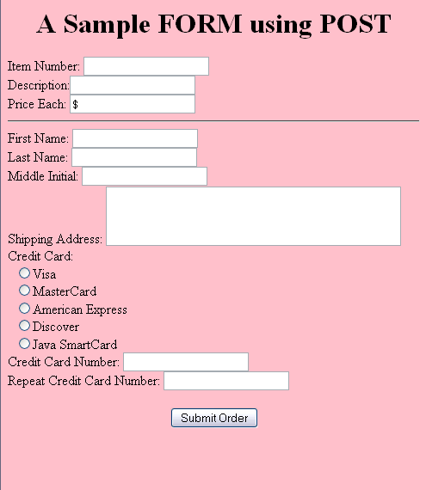

Create a Servlet which reads the data from the above HTML form and display the output in the following format

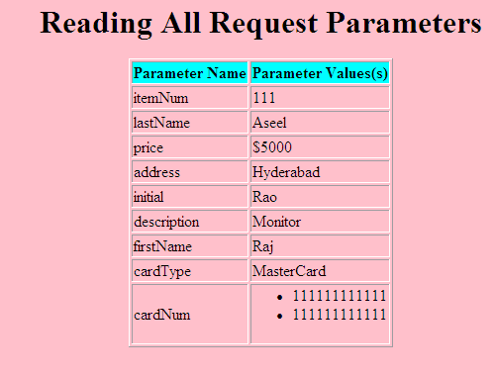

1. Create the following Books table in Oracle

|  |  |  |  |
| --- | --- | --- | --- |
| BookNo | BookName | Author | Price |
|  |  |  |  |
|  |  |  |  |
|  |  |  |  |

Create an HTML as follows

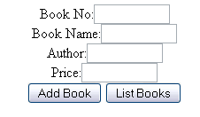

If the user clicks on Add Book button, it should store the details of the book in Books table. If the user clicks on List Books button, it should display the list of books in Books table in table format. Create BooksServlet to do this application

1. Create an HTML form as below

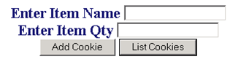

Create a servlet which reads the values entered in the above HTML form.

When the user clicks on Add Cookie, it should add the item details in the Cookie.

If the user clicks on List Cookies, it should display all the Item details which are added to Cookie.

**JSP Assignments**

1. Create a JSP page which finds the factorials from 1 to 5 in the displays the page in the following format

Factorial (1) : 1

Factorial (2): 2

Factorial (3): 6

Factorial (4) : 24

Factorial (5) : 120

1. Create an admin table as given below:

Create table admin(username varchar(10),password varchar(10));

insert into admin values('admin','admin');

Create books table as given below.

Create table books(booktitle varchar(10),author varchar(10),pages number(4),

copies number(4), price number(4),shelfno number(3));

Create a login html page as below:

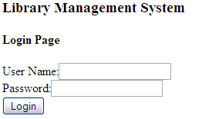

If the user is authenticated, display the following page using login.jsp and Menu.jsp

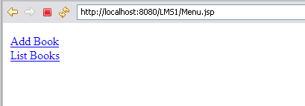

If the user clicks n Add Book link then it should display the following screen

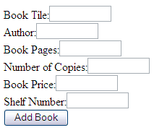

If the user clicks Add Book button it should add the details into Books table and displays the following page.

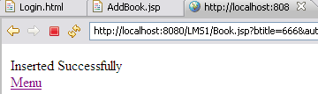

If the users clicks on Menu it should display Menu back.

If th e user clicks on List Books in Menu, it should display the books available in Books table in Table format.

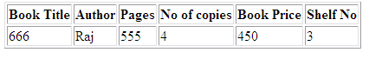

1. Create a Java Bean class Student with attributes rollNo, Name, mark1, mark2, mark3. Create setters and getters

Create a database table Student with columns rollno, name, mark1, mark2, mark3, total

Create an HTML form which reads the values rollNo, Name, mark1, mark2, mark3. When the user clicks on submit, it should call a JSP page which reads the form data using <jsp:useBean> and sets the properties to Student bean class.

Create another JSP page which gets the data of Student class using <jsp:getProperty> and calculates total marks and stores the student details in the Student table

Create a JSP which display the records present in the Student table in table format.

**JSP Custom Tags**

1. Create a custom tag <myfont> which takes 3 attributes

style - optional , default value is “arial”

size – optional, default value is “3”

color – mandatory

1. Create a custom tag <sum> which takes two arguments

from – mandatory

to – mandatory

Eg: <sum from=”1” to=”10”> should display sum of numbers from 1 to 10

1. Create a Custom tag <prime> which takes two arguments

from - mandatory

to – mandatory

Eg: <prime from=”1” to=”10”> should display prime numbers from 1 to 10